Project Planning Phase
Project Planning Template (Product Backlog, Sprint Planning, Stories, Story points)

Date | 30 September 2026
Team ID | SWTID-2026-1669
Project Name | AI WEATHER WISE APL
Maximum Marks | 5 Marks

Product Backlog, Sprint Schedule, and Estimation (4 Marks)
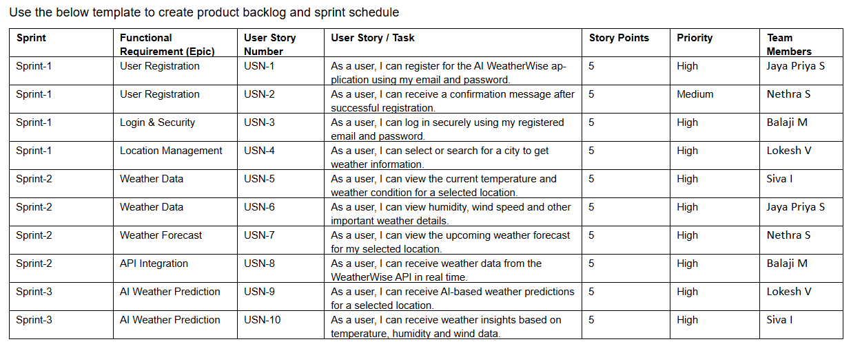

Project Tracker, Velocity & Burndown Chart: (4 Marks)

